**Benefits of Cognitive Computing for Speech Recognition**

**Cognitive Computing has become an important field of research in many fields of industries. Such potential application is also in the area of speech recognition.**

**The applications of Cognitive Computing to speech recognition has potential to vastly improve accuracy and speed of speech recognition. They use audio input to recognize and transcribe spoken words, while synthesis systems convert text into speech.**

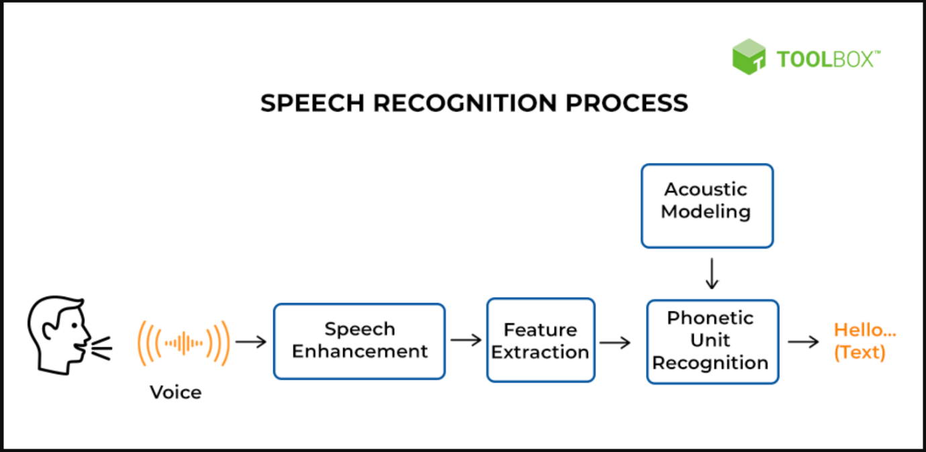

**Cognitive computing algorithms can also be used to improve the accuracy and speed of speech synthesis systems by providing more accurate representations of the audio/text input. This can help speech recognition systems more accurately understand what is being said.**

**Overall, cognitive computing has the potential to revolutionize the accuracy and speed of speech recognition and synthesis systems. This could have far-reaching implications for a wide range of industries, from healthcare to customer service. As cognitive computing continues to advance, it is likely that it will become increasingly important for many applications in the years to come.**

**Source:** [**https://ts2.space/en/the-benefits-of-cognitive-computing-for-speech-recognition-and-synthesis/**](https://ts2.space/en/the-benefits-of-cognitive-computing-for-speech-recognition-and-synthesis/)

